Maintenance plan

Maintenance Plan

It is of outmost importance for a database to have a maintenance plan. Our maintenance plan is a set of practical phases which will need to be completed on a regular basis, on the database, to ensure satisfactory performance of the database as well as convenience. These maintenance acts are performed by the authorized and authentic system administrators of the database.

# The following are the maintenance tasks:

* Check Database Integrity
* Reorganize index
* Update statistics
* History cleanup
* Back up database (Full)
* Back up database (Differential)
* Back up database (Transaction log)
* Maintenance clean up

1. Check database integrity

In most cases, database administrators make use of backup from the existing database without structural and consistency check of the database, and could most likely backup data page-corrupted databases. Therefore to achieve administrative diligence, administrators should regularly verify that the database does not have any corruption. The SQL Server provides a built-in command, DBCC CHECKDB, for just this purpose. When this command is run on a database, it checks both the logical and physical integrity of all objects in that database. If the command finds any problems, it will display them in a report. It is very important to run the Database Check Integrity task on all the SQL Servers, as it is the only way to definitely know if the databases and the backups are in good shape or not.

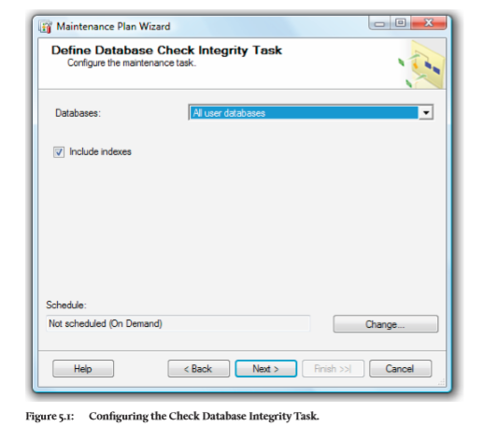

1. Reorganize index

Index fragmentation is an issue all databases experience and, if it is not removed on a regular basis, it can lead to query performance problems. One way to remove index fragmentation is to regularly run the Reorganize Index task, which minimizes space and logical fragmentation in database indexes. The T-SQL provides a built-in statement, ALTER INDEX, for just this purpose.

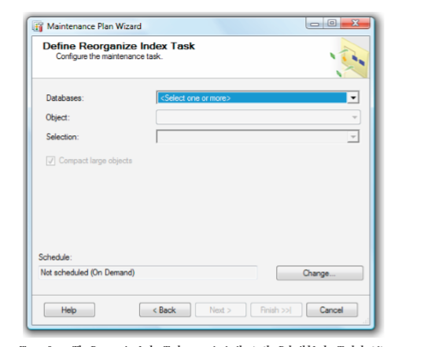

1. Update statistics

The update statistics task updates Microsoft SQL Server information about the data in the tables and indexes. This task resamples the distribution statistics of each index created on user tables in the database. The SQL Server provides a built-in command, UPDATE STATISTICS, for just this purpose.

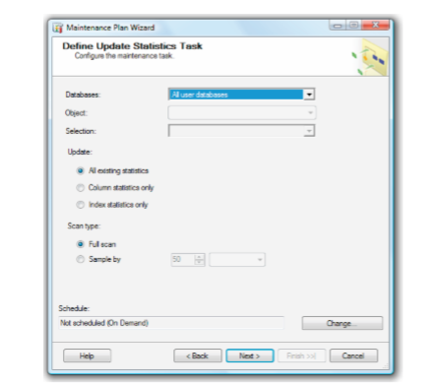

1. History cleanup

The **History Cleanup Task** discards old historical information from tables in the msdb database. On average, a busy server has lots of jobs running on it every day, the msdb database grows in size due to all the historical data it is storing, often leading to performance problems when SSMS accesses it. While this won't prevent work being done, it can slow it down. And since most of the historical data is of no value, it might as well be cleaned out, helping msdb and SSMS to run more efficiently.

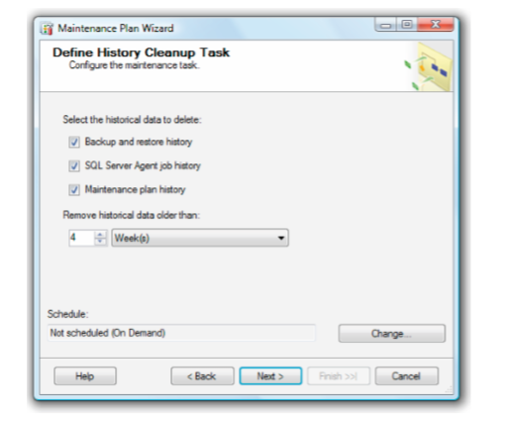

1. Back up database

The basic purpose of a backup of a SQL Server database is to make a copy of the data so that it can be used to restore a database in the event of a disaster, such as system failure, damage to the database, corruption of the data it contains, and so on. Of all the Maintenance Plan tasks that need to be performed, this is the most important. It is critical that full backups of the production databases are made on a regular basis, preferably once a day. A full backup can be performed on any database in SQL Server (expect for tempdb), no matter what recovery model it uses.

# There are three basic types of database backups:• Full backup – backs up all the data in the database. This is essentially making a copy of the MDF file(s) for a given database.

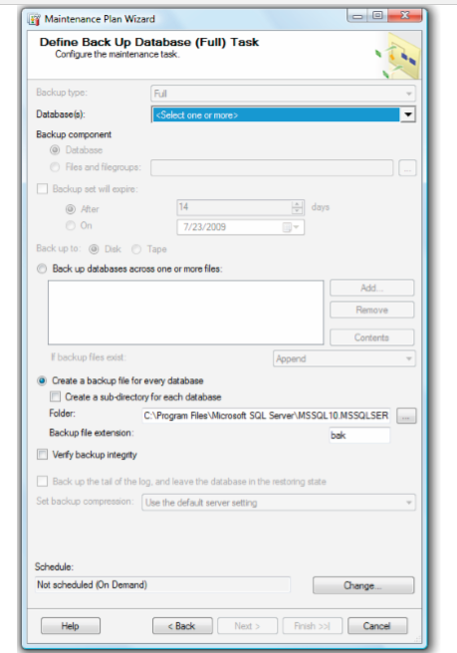

• Differential backups – a backup of any data that has changed since the last full backup. In other words, a differential backup makes a copy of any data in the MDF file(s) that has changed since the last full backup.

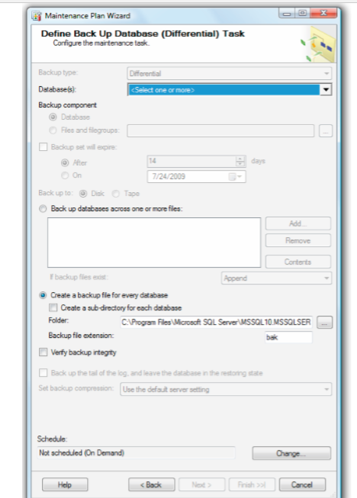

• Transaction log backups – a backup of the transaction log (LDF) file, which stores a history of the actions performed on the data since the last log backup (or database checkpoint if working in simple recovery mode). When a log backup is made, the live transaction log generally gets truncated to remove the backed up entries.

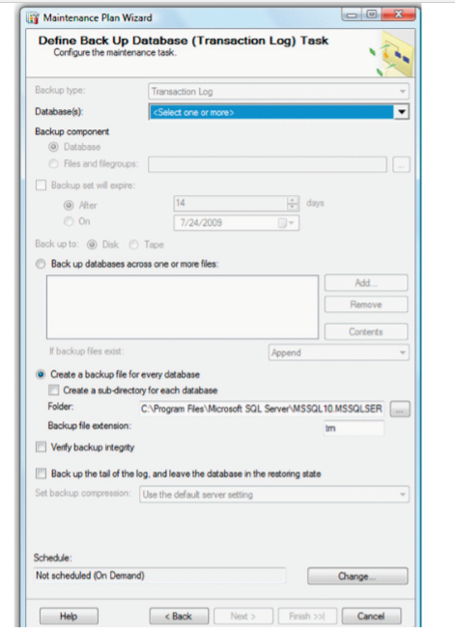

1. Maintenance clean up

The Maintenance Cleanup task removes files related to maintenance plans, including database backup files and reports created by maintenance plans. This is to remove old files that are no longer needed, and the Maintenance Cleanup task can be configured to delete files that have reached a specified age. This to avoid overhead cost for the storage space, and also ensure and retain enough space on the disk for the next successful backup.

